CHANAKYA UNIVERSITY   
  
 NAME: PRADEEP.P.B

SECTION – D   
REG NO – 24UG00558  
BRANCH – ELECTRONICS ENGINEERING   
SUBJECT - DSA

**1.Visit a page-**

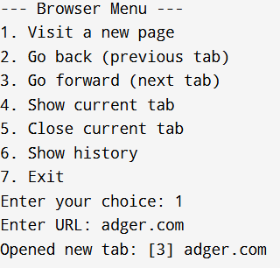

**2.Go back -  
**

**3.Go forward -  
4.Show current tab-  
**

**5.Close current tab -  
6.Show history -  
  
  
  
  
7.Exit-  
**